**Module: SV for Verification**

**Section:** Modules & Classes **Task:** Or Gate Model

**OR Gate Model -** [**EDA Playground**](https://www.edaplayground.com/x/SMtL)

* **DUT:**

// Or_Gate Model

// Author: Noman Rafiq

// Dated: Aug 28, 2024

module dut ( input logic A, B,

output logic E);

wire C, D;

and g0(C, A, B);

not g1(D, B);

and g2(E, C, D);

endmodule

* **Testbench:**

// Testbench

module tb;

reg A, B;

wire E;

dut m1(.A(A),

.B(B),

.E(E));

initial begin

A = 0;

B = 0;

$display("Inputs: A = %b, B = %b", A, B);

$display("Output: E = %b", E);

#40;

A = 1;

$display("Inputs: A = %b, B = %b", A, B);

$display("Output: E = %b", E);

#20;

B = 1;

A = 0;

$display("Inputs: A = %b, B = %b", A, B);

$display("Output: E = %b", E);

#20;

A = 1;

B = 1;

$display("Inputs: A = %b, B = %b", A, B);

$display("Output: E = %b", E);

#20;

A = 0;

B = 1;

$display("Inputs: A = %b, B = %b", A, B);

$display("Output: E = %b", E);

$finish;

end

endmodule

* **Output:**

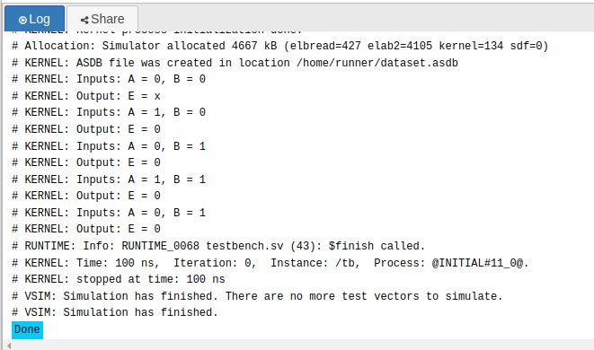

[**EDA Files**](https://www.edaplayground.com/x/SMtL)